Book-o-Ween on Thursday, October 31st

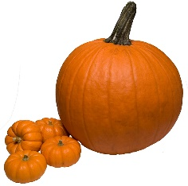

[This Photo](http://www.akidsphoto.com/objects/pumpkin06.html) by Unknown Author is licensed under [CC BY-SA](https://creativecommons.org/licenses/by-sa/3.0/)

Dear Parents,

On Thursday, October 31st, BridgePrep will host “Book-o-Ween”, a celebration highlighting characters from our favorite storybooks! Your child is invited to come to school dressed as a character from one of their favorite storybooks. Additionally, they are asked to bring the book to school. If your child does not have the book, please check it out from the library! During class, your child will share what they learned about the character from their book.

You CAN:

* Dress as your favorite character from a book
* Bring a change of uniform clothes if necessary
* Bring the book that goes with your costume
* Bring a SMALL treat or trinket for the entire class

Please DON’T:

* Wear a costume not related to a book
* Wear a mask
* Bring accessories such as swords or weapons
* Wear a scary costume such as Dracula, ghosts, zombies, etc. *Remember this is BOOK-O-WEEN!

**Be creative! Pinterest has GREAT ideas!**

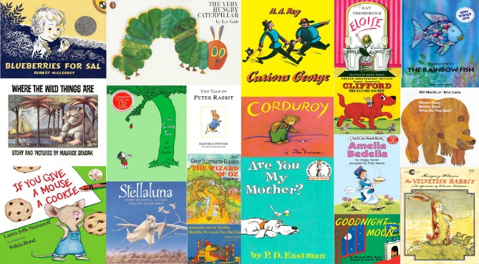

[This Photo](http://www.selfpublishingreview.com/2013/10/creating-attention-grabbing-childrens-stories-in-a-tech-driven-world/) by Unknown Author is licensed under [CC BY-NC-ND](https://creativecommons.org/licenses/by-nc-nd/3.0/)